**Testing**

The landing page requests login credentials before the dashboard can be accessed. *Figure* 1 shows the server requesting user to input login fields. Correct credentials can lead to dashboard home while incorrect credential is dismissed and followed by a subsequent login request.

Figure1. Smart Home Authentication

*Figure* 2 shows server return 401 unauthorized error, this page is returned when the authentication request is cancelled by the user.

Correct credentials “admin” for username and “admin” for password leads to the dashboard homepage. *Figure* 3 shows the ESP32 Smart Home Dashboard.

Figure 2. Returning 401 Unauthorized Error

Figure 3. Landing Page Upon Successful Login

A successful logout is shown in *Figure* 4. To complete the logout process, user must close all browser tabs. Logout can be achieved by clicking Logout button as shown in *Figure* 3 (top right).

Figure 4. Logged Out Page

Webpages that are indexed are properly displayed by the web browser but missing or unindexed pages that might come from the URL must be handled properly. *Figure* 5 shows URL navigation to “some-other-page”, a page that does not exist. Therefore, in response, ESP32 server has sent a “404 Page Not Found” error.

A successful login and dashboard homepage is shown on *Figure* 40 along with sidebar navigation to three other pages: Lights, Appliances, and Climate. The user icon on top right can be used to log out from the dashboard.

Figure 5. Handling 404 Page Not Found Error

Figure 40. Smart Home Landing Page

Figure 6. Front Door On

Front door is turned on in the web browser (see *Figure* 6).

Figure 7. Front Door LED On

Front door LED can be seen in the on state in the breadboard as shown on *Figure* 7.

Back door is turned on in the web browser (see *Figure* 8).

Figure 8. Back Door On

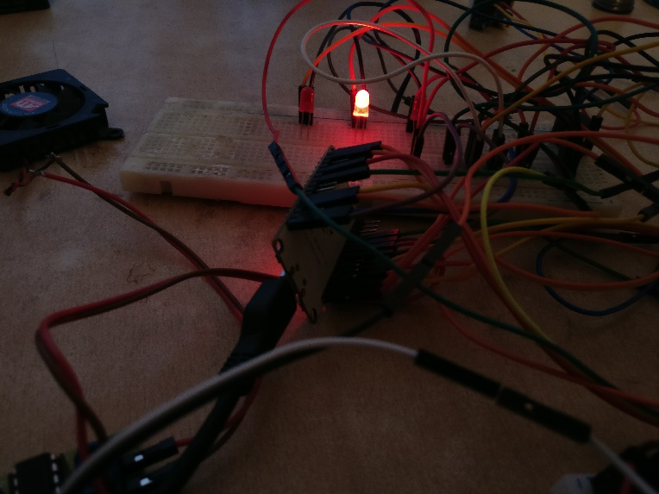

Figure 9. Backdoor LED On

Back door LED can be seen in the on state in the breadboard as shown on *Figure* 9.

Figure 10. Security System Armed

Security system is activated and is on armed state as shown on *Figure* 10. *Figure* 11 shows serial monitor that prints “Motion Detected” message whenever motion is detected. It also applies voltage across piezoelectric buzzer upon motion detection.

*Figure* 12 shows opening of a garage door. Whenever garage door is opened, servo shaft position changes. *Figure* 13 shows a standard servo rotating shaft upon receiving open command from web browser.

Figure 11. Motion Triggered Siren Alarm

Figure 12. Garage Door Open

Figure 13. Servo Shaft Rotated

Figure 14. Fan 10 Seconds Timer On

The timer slider is set to 10 seconds and switch is toggled for fan (see *Figure* 14).

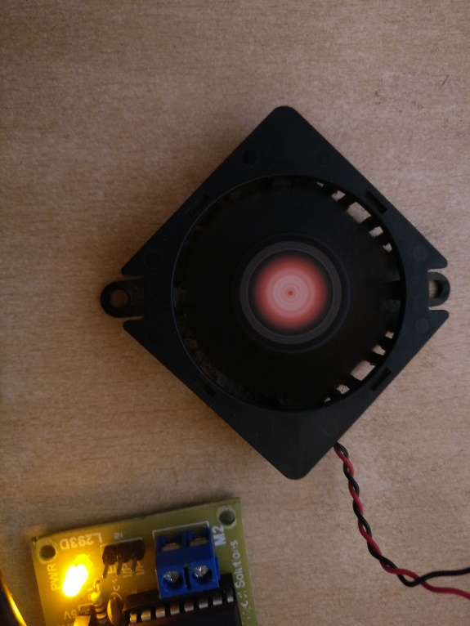

Figure 15. Fan On for 10 Seconds

The fan is turned on and switches off automatically upon scheduled time. *Figure* 15 shows brushless motor driven by motor driver IC.

Figure 16. Selecting Cyan Colour

On festival light card in the dashboard, cyan colour is picked. The colour picker can pick a distinctive combination of 16.8 million colours. Eight-bit binary digits have 221 possible combinations, total number of subsets = 28 = 221 combinations. Red, Green, and Blue component of RGB LED can have 221 x 221 x 221 = 16.8 million possible combinations.

Figure 17. Lit Cyan Colour

Figure 18. Bedroom Light Dimmed to 10 Percent

On bedroom card, light brightness is set to 10% as shown in *Figure* 18.

Figure 19. Bedroom LED Dimmed To 10 Percent

Light can be seen dimmed down to 90% (10% brightness) as seen in *Figure* 18.

Figure 20. Garage Light Turned On

On *Figure* 15, gas leakage card is expanded and the form with email address and gas threshold level are filled and submitted.

Figure 21. Set Gas Leakage Email Alert

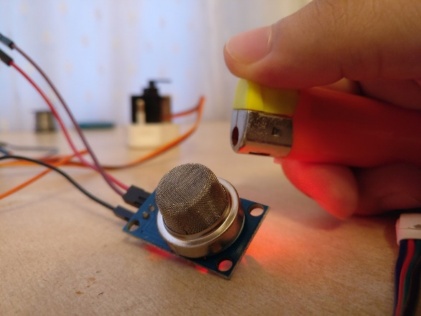

Figure 57. Butane Gas Passed To Sensor

*Figure* 57 shows MQ-2 gas sensor exposed to butane gas, if threshold is crossed, event is triggered.

*Figure* 22 shows serial monitor connecting to SMTP server and delivering alert email.

Figure 22. Email Triggered On Serial Monitor

Figure 23. Gas Leakage Email Alert Sent

A gas alert email has been received as top priority email (see *Figure* 15).

Figure 24. Temperature and Altitude Charts

Figure 25. Altitude and Pressure Charts

*Figure* 24 and *Figure* 25 shows charts with data plots on each sensor readings on the climate page. Top graph shows temperature readings followed by altitude readings and pressure readings at the end.

**Evaluation**

Evaluation of product was done to determine whether or not it fulfilled the set objectives. The following table compares the initially expected outcome to the resulting outcome.

|  |  |  |  |
| --- | --- | --- | --- |
| **Features** | **Initial Expectation** | **Resulting Outcome** | **Evaluation** |
| Gas Leak Detection | Detects the level of smoke and gas and determines if the value crosses the set threshold level | Gas and smoke leak detection was done and was as intended. | Success |
| Notification via e-mail of Gas leak threshold | Users will be emailed of potential fire hazard caused by flammable gas leakage when the set threshold value is crossed. | When the set values of threshold were crossed by the smokes and gas, the user was notified through email | Success |
| Automate turning on/off LEDs | LED light should turn on/off when the homeowners are connected to network with the help of buttons | The LEDs was able to be switched on/off using toggle switch | Success |
| Change Color of LED Strips | Change the color of light among 16.8 million combinations available as per the user's preference | LED strip's color could be changed using color picker to meet the homeowner's taste. | Success |
| Measure Temperature and Pressure | The System should be able to accurately measure Temperature and Pressure of the room and provide a real time information as provided by the sensors | Current values of Temperature, Pressure, was measured and was accessible to the users in the webapp. Later the current altitude was also shown. | Success |
| Motion Detection and Notification | The System should detect motion and notify owners of such an event | Motion was detected using PIR sensor and would activate sirens to alert the homeowners | Success |
| Automation of Fan using timer | Users should be able to time the fan when they are connected to the home-network | The owners were able to control the time for the fan. | Success |

As the initial requirement of the product was met efficiently, and was implemented, the product was deemed a success.